Modul 3 (CSS)

Nama : Melia Inda Sari

NIM : 2402020021

1. CSS element Selector

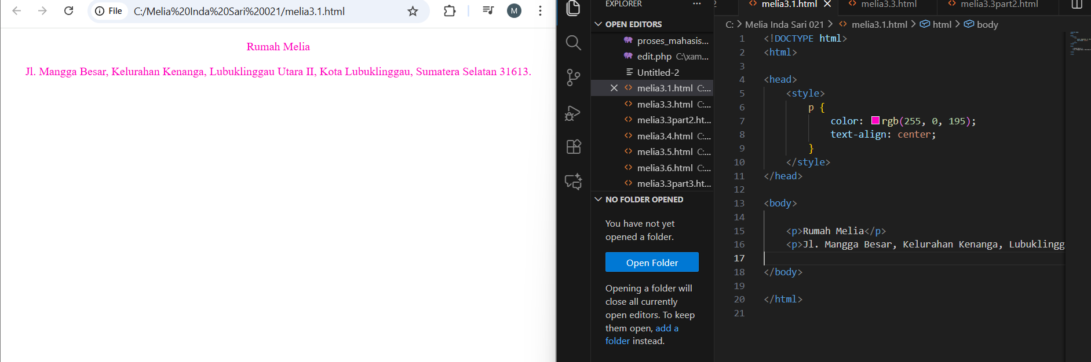

2. CSS id Selector

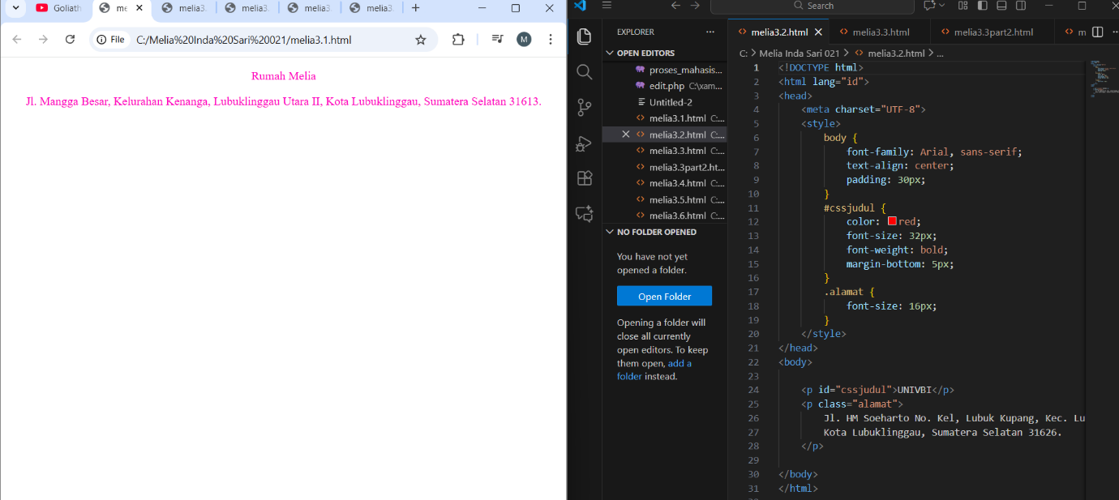

3. CSS class Selector

- 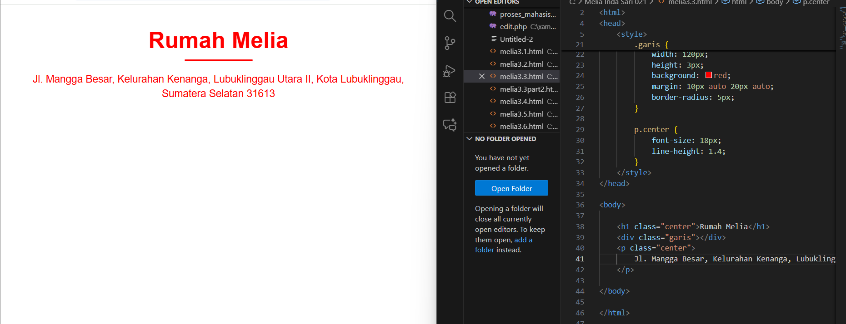

- 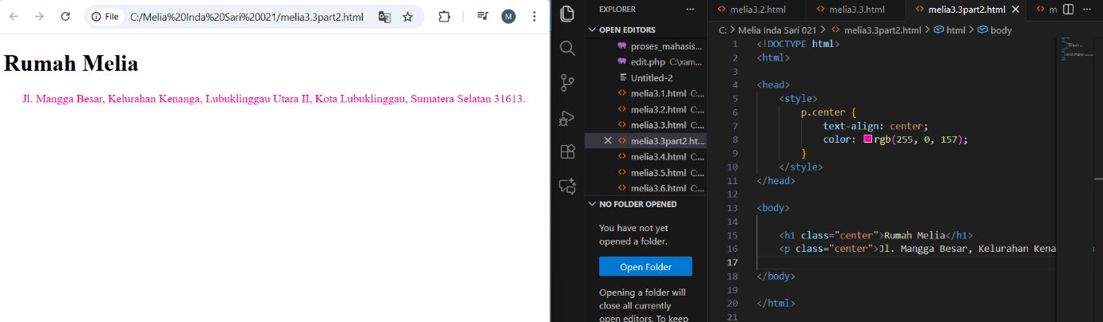

- 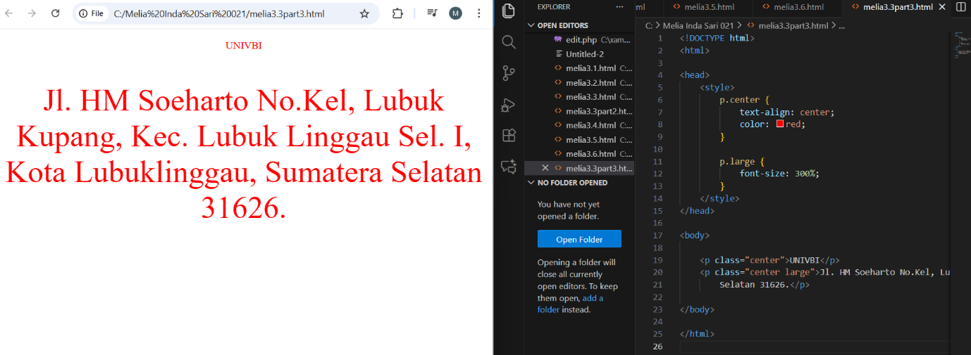

4. Universal CSS
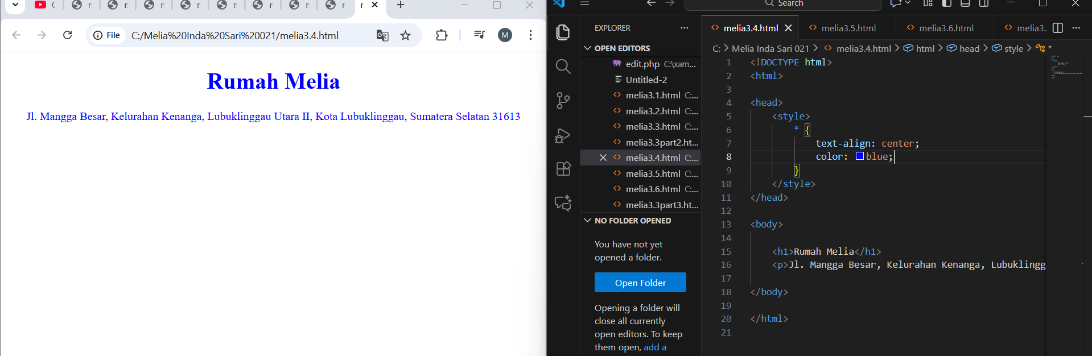

5. Pengelompokan CSS
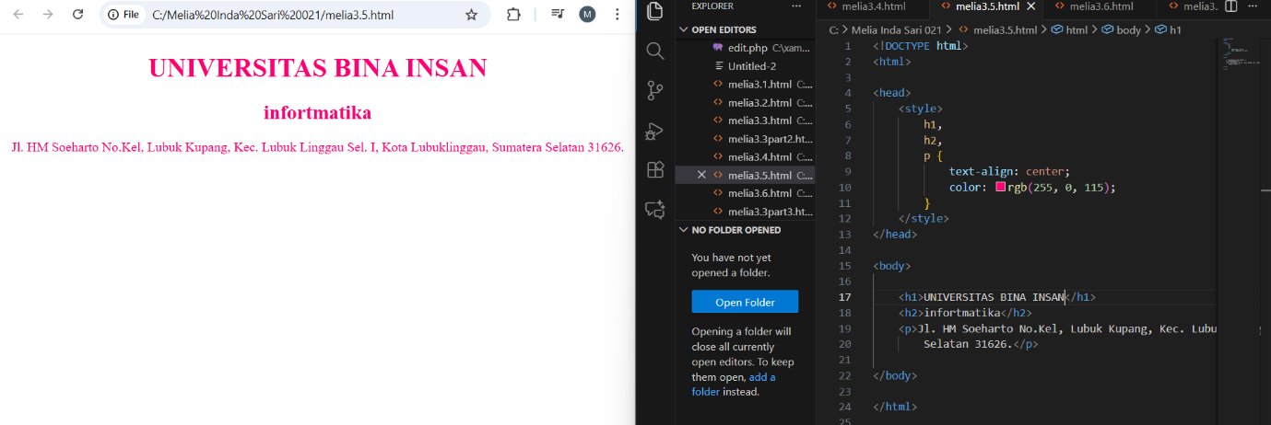

6. CSS Eksternal

